**Five Ways to Wellbeing – Developing Positive Mental Health and Wellbeing**

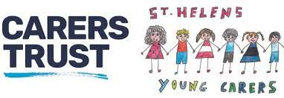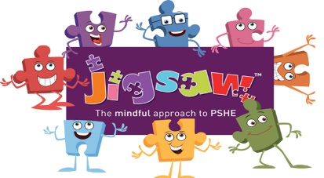





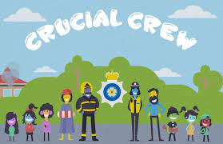





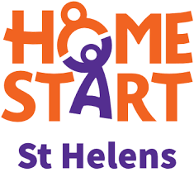

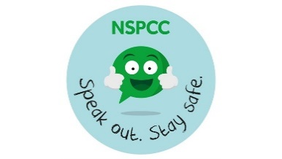

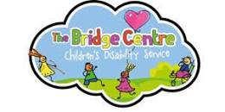





# Whole school approach to developing 5 ways to Wellbeing for all stakeholders.

Each year in Autumn 1 we will introduce/revisit the 5 Ways to Wellbeing.

World Mental Health Day will be used as a further opportunity to develop this understanding at an overall level.

To deepen understanding for our children in each separate area, each half term from Autumn 2 to Summer 2 we will take part in 6 weeks of Wellbeing activities. These will focus on the 5 Ways to Wellbeing – Connect, Keep Learning, Take Notice, Be Active and Give.

**The outline**

Week 1 – Assembly outlining the importance of that half term’s focus.

Week 2 – A home activity that parents can tweet/post on class dojo.

Week 3 – An in-class activity to do on a Wednesday.

Week 4 – Pupil leadership/Reading Ambassador/Sports Ambassador will plan and partake in an activity based on the playground.

Week 5 – A whole school activity which will involve a KS2 class paired with a KS1 class.

Week 6 – A staff wellbeing activity to create a whole school approach towards wellbeing.

**OVERVIEW:**

|  |  |  |  |  |  |  |
| --- | --- | --- | --- | --- | --- | --- |
|  | **AUTUMN 1** | **AUTUMN 2** | **SPRING 1** | **SPRING 2** | **SUMMER 1** | **SUMMER 2** |
| **APPROACH** |  | **Connect** | **Keep Learning** | **Take Notice** | **Be Active** | **Give** |
| **JIGSAW** | **Being Me in My World** | **Celebrating Difference** | **Dreams and Goals** | **Healthy Me** | **Relationships** | **Changing Me** |
| **WEEK 1** | Jigsaw assembly | Jigsaw assembly  Five ways to wellbeing assembly outlining the means and activities that will take place that coming term. | Jigsaw assembly  Five ways to wellbeing assembly outlining the means and activities that will take place that coming term. | Jigsaw assembly  Five ways to wellbeing assembly outlining the means and activities that will take place that coming term. | Jigsaw assembly  Five ways to wellbeing assembly outlining the means and activities that will take place that coming term. | Jigsaw assembly  Five ways to wellbeing assembly outlining the means and activities that will take place that coming term. |
| **WEEK 2** |  | Complete a home activity – connecting with a friend or family member. | Learn a new skill at home or an activity that they take part in. | Complete a yoga or mediation activity at home. | Complete an exercise activity at home, e.g. – football match, going to the park, running/skipping on the spot. | Children to do something nice for someone else, e.g. giving their time to someone, giving someone a hug, making a card for someone, giving to the local community. |
| **WEEK 3** |  | In class activity:  This will be pairing up with another child from their class who they wouldn’t usually connect with and read a book of their choice with one another. | In class activity:  Complete the sheet ‘find someone who’ to help them learn more about their class friends. | In class meditation:  Taking notice to the world around them, using their 5 senses. Discussion to take place about how important it is to stop and take notice to the world and our surroundings. | In class activity:  Children will complete an activity circuit outdoors during playtime. | In class activity:  The class teacher to give the class a ‘good deed’ note that they try and complete during schooltime and at home. |
| **WEEK 4** |  | Maths Ambassadors will organise a games club at lunchtime. | Pupil Leadership will teach the children a song, dance, game, etc, during lunchtime. | Science Ambassadors will organise a nature walk at lunchtime. | Sport Ambassador will set up an activity outside during lunchtime. | Reading Ambassadors to organise a book swap. |
| **WEEK 5** |  | Whole school activity: KS2 to pair up with a class in KS1 and they will take part in an activity together. | Whole school activity: KS2 children to come and teach KS1 children a phrase in Spanish. | Whole school activity:  Teachers to choose a piece of music for another class to listen to. | Whole school activity:  Children to complete a daily mile walk/run. | Whole school activity:  Collection for a food bank in our area. |
| **WEEK 6** |  | Staff to volunteer to join in with our Rivi Let’s Talk podcast. | All staff will learn a new skill. | A yoga teacher will come in to complete an hour of yoga and meditation. | Wellbeing staff meeting time will be ‘walk and talk’ after school. | Tea and Talk for staff during lunchtime. |

Happiness at work week – 23rd-27th September 2024

World Mental Health Day – 10th October 2024 – It is time to prioritize mental health in the workplace.

World Menopause Day 18th October 2024

Children’s Mental Health Week – 3rd-9th February 2025

World Sleep Day 14th March 2025

International Day of Happiness – 20th March 2025

Mental Health Awareness Week – Mid May 2025