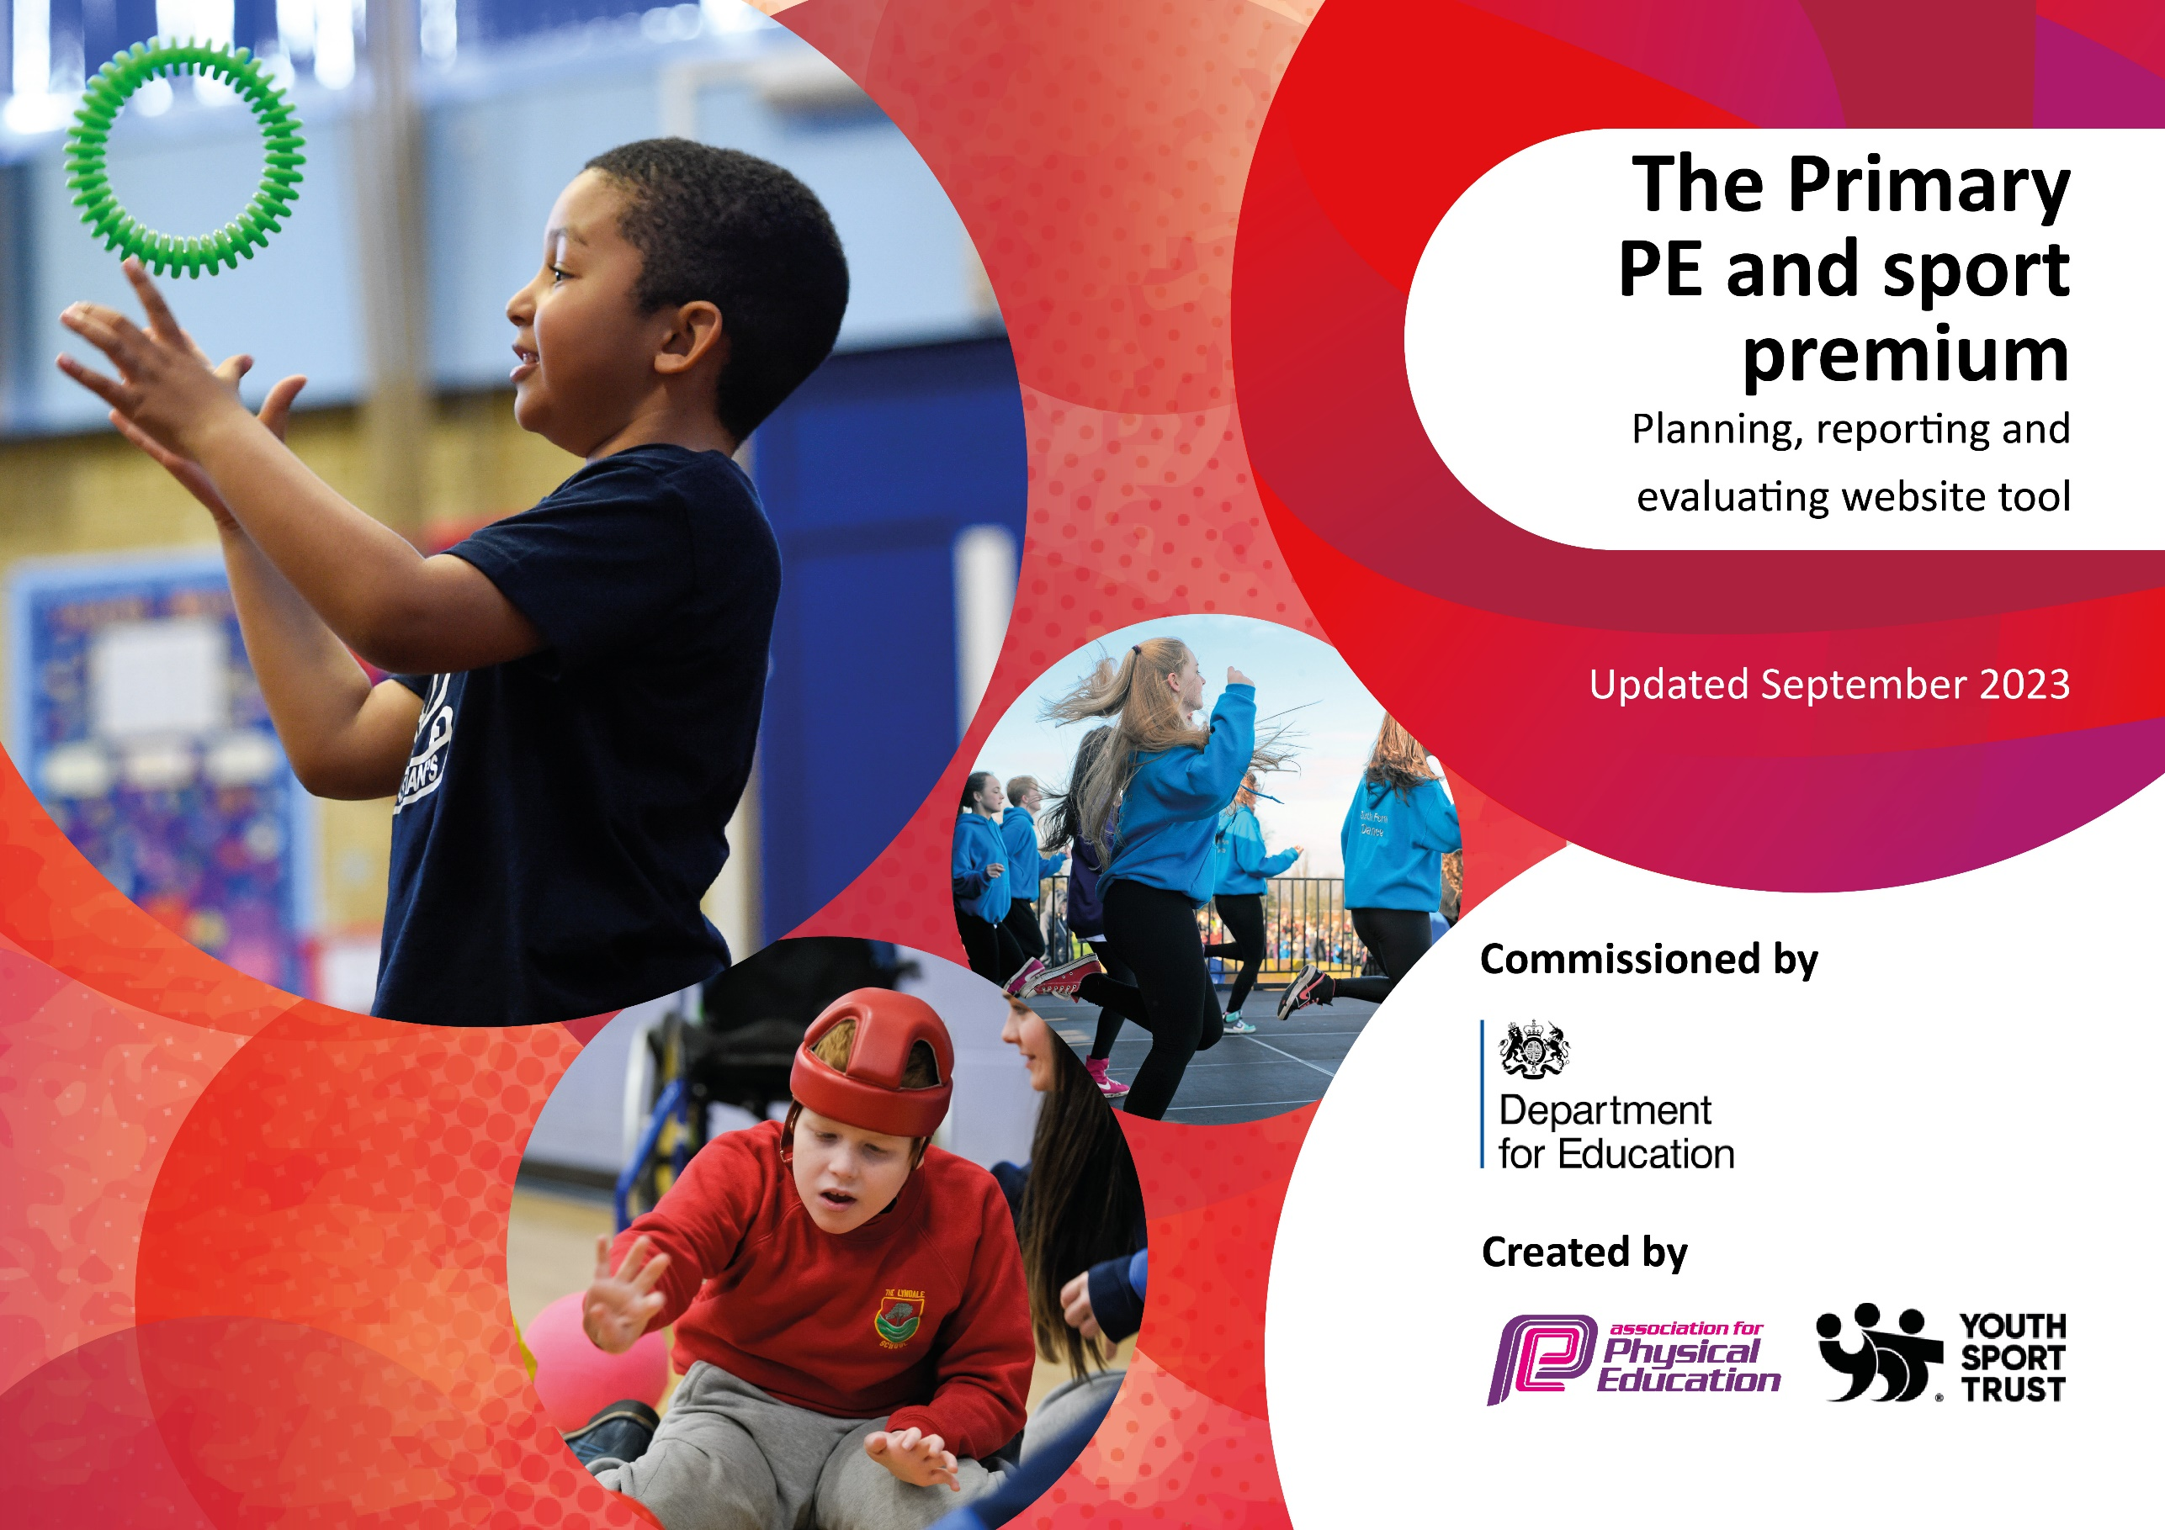

Key priorities and Planning
This planning template will allow schools to accurately plan their spending.

Action – what are you planning to do | Who does this action impact? | Key indicator to meet | Impacts and how sustainability will be achieved? | Cost linked to the action
To increase the confidence, knowledge and skills of KS2 staff in teaching Dance across the school.  To raise the profile of Dance within the school. | KS2 teaching staff will observe the dance sessions and team teach alongside the specialist dance teacher to gain improved subject knowledge and confidence.  Pupils will take part in high quality curriculum dance sessions resulting in increased learning outcomes in dance.  Lucy Waterhouse – specialist dance teacher. | Key Indicator 1: Increased confidence, knowledge, and skills of all staff in teaching PE and sport.  Key indicator 4: Broader experience of a range of sports and activities offered to all pupils. | Increased confidence and knowledge of teaching staff in delivering dance lessons following the CPD sessions. Teachers will benefit from expertise of a trained coach who will provide ideas for future lessons.  Increased pupil learning and development in Dance. | Specialist dance teacher £3200
To work towards improving percentage of children who are meeting national curriculum requirements for swimming and water safety by end of Y6.  CPD opportunity for staff to further develop teaching confidence and skill in teaching swimming.  To boost targeted swimming groups in each junior class.  To ensure consistent approach across KS2 swimming and highlight targeted groups for additional swimming support on Mondays. | Subject lead to work with teaching staff and children throughout the year with swimming continuing to be an ongoing focus this year. Subject lead to offer additional top up swimming for non swimmers.  Increased percentage of children meeting the National Curriculum requirements for swimming and water safety.  All weekly swimming lessons to be hour session in pool as opposed to recommended 30 minute lessons. | Key Indicator 1: Increased confidence, knowledge, and skills of all staff in teaching PE and sport. | The impact of the swimming CPD and interventions this year has had a significant impact across all classes in KS2 with percentages of children meeting the expected national curriculum standard in swimming increasing in each year group.  As a result the expected standard at the end of primary school was reached by the majority of pupils who attended weekly swimming lessons (80% could swim 25 metres confidently).  Teachers have gained increased confidence from working alongside experienced specialist teachers.  The gap in swimming attainment between all pupils has continued to narrow from previous years. | Subject leader to be released to work with staff and children for weekly swimming  lessons on Monday mornings.  £2804
To engage all pupils in regular physical activity and to meet the Chief Medical Officer guidelines recommendation that all primary school pupils undertake at least 30 minutes of physical activity a day in school.  All children will be physically active and take part in physical games and activity in the playground areas at both breaks and lunch times across all key stages daily.  To introduce some structured physical activity in children’s lunchtimes though the use of high quality lunchtime sport activity clubs. | PE coordinator to complete Activity/Sports leader training programme with all children in Y6 during Autumn 2023. Following this the children are then offered the opportunity to develop vital leadership and inter personal skills though physical activity.  Activity leaders to plan and deliver multi skills sessions and playground games at lunchtimes.  Activity leaders to be involved in the organising, setting up and leading whole school intra competitions and events.  Selected activity leaders to be part of the school’s Sports Committee and attend half termly meetings with the PE Coordinator.  Sports coach to lead activities at lunchtimes.  Pupils should have increased enjoyment at lunchtimes. | Key indicator 2: The engagement of all pupils in regular physical activity – the Chief Medical Officer guidelines recommend that all children and young people aged 5 to 18 engage in at least 60 minutes of physical activity per day, of which 30 minutes should be in school. | The percentage of children active at break and lunchtimes has increased so the majority of children will engage in some daily physical activity during outdoor playtimes across the school day.  Y6 have undertaken activity leader training and have devised and led playtime multi skills activities sessions. The activity leaders have also been involved in organising, leading and evaluating some of the whole school intra school events across the year.  - Increased enjoyment of playtimes.  - Improved behaviour at outdoor playtimes and less recorded incidents due to children’s engagement in activities and being more active.  - Improved learning during afternoon sessions. | Steve’s Coaching  £720  PE Coordinator release for Activity/Sports leader training in Y6 during Autumn 2023. £200  This action will be further developed in 2024/2025 with the introduction of OPAL.
To raise the profile of sport through the provision of rich sporting experiences which aspire our children.  To provide our children with termly enrichment days to give all our children the opportunity to participate and experience a range of new sports such as Drumba, triathlon and glow in the dark dodgeball. | PE Coordinator to arrange and organise termly whole school events at various points throughout the year to provide all children with a broad experience of a range of sports and activities in addition to what is offered within the curriculum.  Pupils will all take part in new experiences and sporting activities across the whole school. | Key indicator 4: Broader experience of a range of sports and activities offered to all pupils.  Key indicator: The profile of PESSPA being raised across the school as a tool for whole school improvement. | All pupils have taken part in a range of new sports and activities such as Drumba, glow in the dark dodgeball and our Explorers OAA Day.  All pupils have had the opportunity to compete within a whole school competition. | Progressive Sports – Glow In the Dark Dodgeball £329  Drumba - £999  OAA Day – £509.40
To increase and provide a range of extra curricular sports and physical activity clubs including introducing new sports and activities. | PE Coordinator to organise half termly a varied programme of after school clubs each half term.  - Arrange the use of sport specialist coaches such as Superstars Gymnastics club, Steve’s Football Academy and Matt Fiddes Martial Arts to ensure children are offered a broad range of high quality extra curricular activities. | Key indicator 4: Broader experience of a range of sports and activities offered to all pupils.  Key Indicator 2 | A broader range of sports and activities offered to all pupils within our extra curricular offer.  Increased participation in a wide range of extra curricular clubs across EYFS, KS1 and KS2. | Superstars Gymanastics - £1260  Martial Arts –  £300
To increase participation in inter school competitions across the school.  To increase opportunities for children to apply their skills in a competitive environment encouraging confidence and determination.  To subscribe to St Helens enhanced local school games provision package (SHAPES) to enable increased access to inter school competitions | All children had the opportunity to compete in intra and inter school competition and events.  PE Coordinator to enter and organise a wide range of competitions each half term.  To raise the profile of competitive sport within the school by celebrating participation and achievements with the whole school community via weekly merit assembly, newsletters and the school website. | Key indicator 5: Increased participation in competitive sport  Key indicator: The profile of PESSPA being raised across the school as a tool for whole school improvement. | This year children from Y2 to Y6 all had the opportunity to represent the school at a variety of different sporting competitions throughout the year.  100% of children have participated in whole school intra competition. | Transport for competitions / Staff release for competitions £268.60  SHAPES subscription  £749
To increase the confidence, knowledge and skills of all staff in teaching OAA across the school.  Arrange OAA Staff training with all staff for Autumn 1.  To invest in Enrich Education school orienteering package to have permanent and bespoke orienteering courses on the school grounds for OAA.  To raise the profile of OAA within the school.  To organise a whole school OAA event day.  To increase staff’s awareness of how OAA can enhance learning in all curriculum subjects and enhance pupil wellbeing. | PE Coordinator to organise staff training and liase with Enrich to have Orienteering course mapped out and installed on the school grounds.  All pupils will experience and take part in high quality OAA sessions and develop their orienteering and outdoor learning skills.  All staff will receive OAA training and develop their confidence, knowledge and skills in delivering OAA within their year group.  All staff to be trained with new Enrich OAA platform. | Key Indicator 1: Increased confidence, knowledge, and skills of all staff in teaching PE and sport.  Key indicator 4: Broader experience of a range of sports and activities offered to all pupils. | All children to experience high quality OAA sessions across the school.  All staff to feel confident in delivering OAA within their year group. | Enrich OAA Training  £1960  Endeavour Learning Trust Outdoor Learning  £4500

Swimming Data
Meeting National Curriculum requirements for swimming and water safety.
Priority should always be given to ensuring that pupils can perform safe self-rescue even if they do not fully meet the first two requirements of the National Curriculum programme of study

Question | Stats: | Further context  Relative to local challenges
What percentage of your current Year 6 cohort can swim competently, confidently and proficiently over a distance of at least 25 metres? | 80%
What percentage of your current Year 6 cohort can use a range of strokes effectively [for example, front crawl, backstroke, and breaststroke]? | 80%

What percentage of your current Year 6 cohort are able to perform safe self-rescue in different water-based situations? | 100%
If your schools swimming data is below national expectation, you can choose to use the Primary PE and sport premium to provide additional top-up sessions for those pupils that did not meet National Curriculum  requirements after the completion of core lessons. Have you done this? | Yes
Have you provided CPD to improve the knowledge and confidence of staff to be able to teach swimming and water safety? | Yes

Signed off by:

Head Teacher: | Mrs Clare Powell
Subject Leader or the individual responsible for the Primary PE and sport premium: | Mrs Claire Latham
Governor: | Mr Chris Halliwell
Date: | 22.07.2024

