Y5 Girls Football Tournament
We were proud of our girls’ football team and their performance in the St Helens Schools Girls Football Competition at Ruskin Drive on Wednesday. The team played really well in all its matches in the group stages, however, a few last minute goals from our opponents resulted in us not making the semi-finals this year. All the children thoroughly enjoyed themselves and are looking forward to future matches.
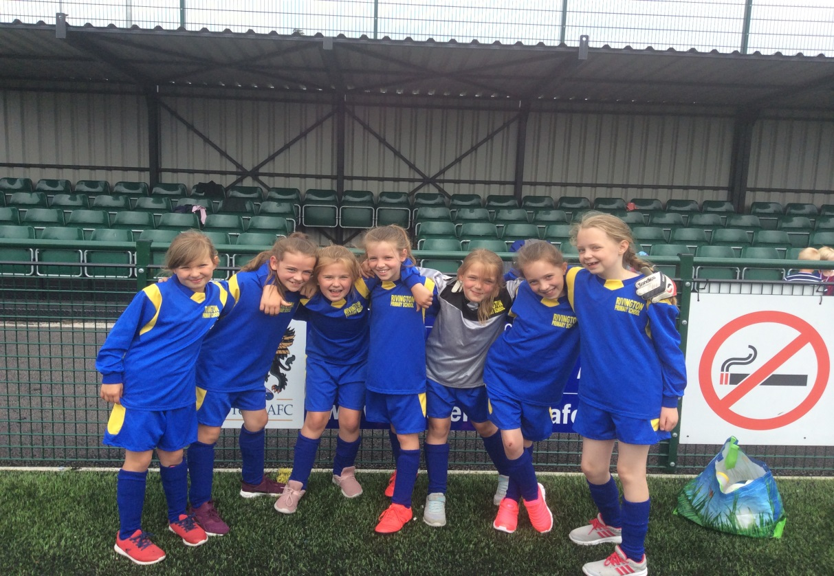
Mr Veitch chosen Skye as his most improved player in today’s competition and the Player of the Match, which is voted for by all the players, went to Elizabeth.
Well done Skye and Elizabeth!

