RIVINGTON PRIMARY SCHOOL

Display Screen Equipment

We invite you to come on an exciting learning journey.
Discover, create, invent, explore. Join the adventure …….

document1

Health & Safety (Display Screen Equipment) Regulations (1992) As Amended

1.0 Introduction

  - The Display Screen Equipment Regulations (1992) as amended, require employers to assess and control the health risks to health and safety arising from the use of display screen equipment.

  - Display Screen Equipment (DSE) is defined within the Regulations as any alpha-numeric or graphic display screen, and includes cathode ray tubes, microfiche and liquid crystal
display screens, plasma and touch screen displays.

  - The Regulations do not cover:-

    - DSE on board a means of transport;
    - DSE intended for public use and those in public libraries and schools
    - Portable systems not in prolonged use
    - Window typewriters
    - Equipment that has a small data or measurement display - calculation cash registers and medical equipment

2.0 Who is a DSE User?

  - An employee will be a 'user' if they satisfy the three criteria given below and one of four further criteria:-

    - the individual normally uses DSE for continuous or near-continuous spells of an hour or more at a time, AND
    - the individual uses DSE in this way more or less daily, AND
    - the individual has to transfer information quickly to or from DSE,

AND ONE OF

    - the individual needs to apply high levels of attention and concentration, OR
    - the individual is highly dependant on DSE, OR
    - the individual has little choice about using DSE, OR
    - the individual needs special training or skills to use the DSE.

3.0 Procedure

  - Section Heads/Line Managers shall identify all employees who are 'users' of display screen equipment.

  - Section Heads/Line Manager shall complete a workstation assessment using the check list attached to this procedure.

  - The Occupational Health/The Corporate Safety Team shall ensure that Managers carrying out assessment have been trained in the use of the assessment checklist. They shall also ensure that completed assessments are suitable and sufficient.

  - All identified risks shall be reduced to the lowest extent reasonably practicable.

  - All purchases of DSE and associated equipment shall be approved by the IT : Strategy and Regulations Section to ensure a consistency of approach and compliance with corporate standards.

  - A copy of the booklet Visual Display Work: Guidance for Staff, concerning health and safety, shall be issued on a recorded basis, to all users of Display Screen Equipment and used as the basis for training and instruction.

  - Users of Display Screen Equipment are entitled, on request, to an eye or eyesight test. In the first instance the Authority provides a vision screening service through the Occupational Health Team. Notwithstanding the results of the vision screen, users may wish to exercise their right to a full eye test provided by a registered ophthalmic optician. In response the Authority has retained Kay's Opticians to provide this service and users wishing must be referred to the Occupational Health Team who will arrange the appointment. Thereafter the frequency of testing will depend upon the advice of the optician and will be co-ordinated by the Occupational Health Team.

  - Where eye and eyesight tests show users to require spectacles to correct vision defects at the specific viewing distance for display screen work, the Authority will meet the cost of basic lenses and frames.

  - Section Head/Contracts Manager/Operations Manager shall inform 'users', of display screen equipment, of the need to take regular breaks away from the screen:-

    - breaks and changes in activity should be included in working time and reduce the workload at the screen; .
    - breaks should be taken when performance and productivity are at a maximum, before the user gets tired;
    - the timing of the break is more important than its length;
    - short, frequent breaks are more satisfactory than occasional, longer breaks. For example, a 5-10 minute break each hour would be better than 15-20 minutes every two hours;
    - users should be allowed discretion as to when to take breaks and how they carry out tasks (but they should not be given total discretion as they may forgo breaks in order to expedite a task);
    - changes of activity away from the DSE appear to be more effective than formal rest breaks in relieving visual fatigue; and
    - breaks should, if possible, be taken away from the DSE workstation (surfing the internet for private use does not constitute a break) and, in an addition in the new guidance, allow the user to stand up, move about and/or change posture.

  - If break monitoring software is used:-

    - care needs to be taken when setting thresholds for the packages;
    - software packages are unable to detect screen-reading time;
    - employers must, in any case, ensure that the work is planned and that the breaks are taken;
    - on-screen "reminders", rather than forced stops or lock-outs, are less likely to frustrate users; and
    - the user should have some scope to configure the package.

4.0 Agency Workers

  - Where an agency worker becomes an employee of the host employer, the host employer assumes the duties of the Regulations. But when the worker is employed by the agency or is self-employed, the duties split. St Helens Council must:-

    - assess the risks to the agency worker;
    - ensure all workstations comply with the minimum requirements of the Regulations;
    - plan activities to ensure breaks from DSE work;
    - provide training when the workstation is modified, and
    - provide information on risks and risk assessment and reduction. The agency shall:-
    - provide eye tests and corrective appliances to their employees;
    - provide health and safety training
    - provide information on eye tests and training; and
    - check that the host employer has assessed the risks from the workstation, ensured that the workstation complies with the minimum requirements, planned for breaks or changes of activity, and provided information.

5.0 Recording your findings

  - For the purposes of recording DSE Risk Assessments the Council uses the HSE VDU Workstation Checklist. Copies of the checklist can be obtained from the Corporate Safety Team (ext 1722/3234).

VDUworkstation checklist

VDU WORKSTATION CHECKLIST

Workstation location and number (if applicable):

User: Checklist completed by: Assessment checked by: Date of assessment:

•
Any further action needed? YES/NO

Regulations.
Follow-up action completed on:
·-

This checklist can be used as an aid to risk assessment and to help comply

with the Schedule to the Health and Safety (Display Screen Equipment)

Work through the checklist, ticking either the 'yes' or 'no' column against each risk factor:
    - 'Yes' answers require no further action.
    - 'No' answers will require investigation and/or remedial action
by the workstation assessor. They should record their decisions in the 'Action to take' column. Assessors should check later that actions have been taken and have resolved the problem.

Remember the checklist only covers the workstation and work environment. You also need to make sure that risks from other aspects of the work are avoided, for example by giving users health and safety training, and providing for breaks or changes of activity.Advice on these is given in: The law on VDUs: An easy guide HSE Books 2003 ISBN 978 0 7176 2602 1

HSE

VDU workstation checklist

RISK FACTORS

Display screens
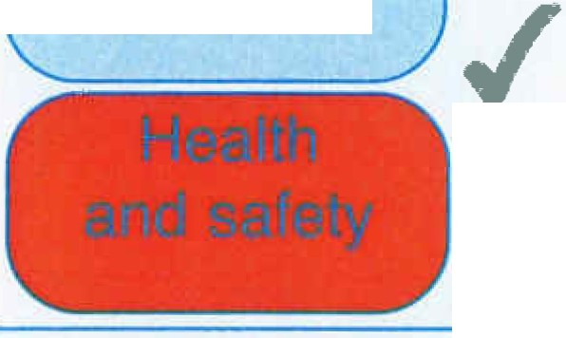

THINGS TO CONSIDER
ACTION TO TAKE

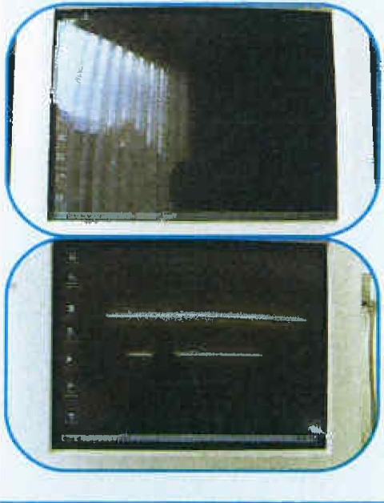

Tick answer YES NO
Are the characters clear and readable?  Health and safety  x  Is the text size comfortable to read? |  |  | Make sure the screen is clean and cleaning materials are made available.  Check that text and background colours work well together.  Software settings may need adjusting to change text size.
Is the image stable, ie free of flicker and jitter? |  |  | Try using different screen colours to reduce flicker, eg darker background and lighter text.  If problems still exist, get the set-up checked, eg by the equipment supplier.
Is the screen's specification suitable for its intended use? |  |  | For example, intensive graphic work or work requiring fine attention to small details may require large display screens.
Are the brightness and/or contrast adjustable? |  |  | Separate adjustment controls are not essential, provided the user can read the screen easily at all times.
Does the screen swivel and tilt?  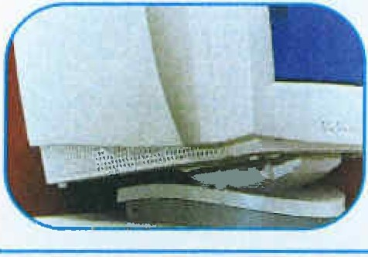  Is the screen free from glare and reflections? |  |  | Swivel and tilt need not be built in; you can add a swivel and tilt mechanism.  However, you may need to replace the screen if:  • swivel/tilt is absent or unsatisfactory ;  • work is intensive; and/or  • the user has problems getting the screen to a comfortable position.  Use a mirror placed in front of the screen to check where reflections are coming from.  You might need to move the screen or even  the desk and/or shield the screen from the source of reflections.  Screens that use dark characters on a light background are less prone to glare and reflections.
Are adjustable window coverings provided and in adequate condition? |  |  | Check that blinds work. Blinds with vertical slats can be more suitable than horizontal ones.  If these measures do not work, consider anti-glare screen filters as a last resort and seek specialist help.

RISK FACTORS

Keyboards
.,
Is the keyboard separate from the screen? |  |  | This is a requirement, unless the task makes it impracticable (eg where there is a need to use a portable) .
Does the keyboard tilt? |  |  | Tilt need not be built in.
Is it possible to find a comfortable keying position?  ./  x x  x |  |  | Try pushing the display screen further back to create more room for the keyboard, hands and wrists.  Users of thick, raised keyboards may need a wrist rest.
Does the user have good keyboard technique? |  |  | Training can be used to prevent:  - hands bent up at wrist;  - hitting the keys too hard;  - overstretching the fingers.
Are the characters on the keys easily readable? |  |  | Keyboards should be kept clean. If characters still can't be read,the keyboard may need modifying or replacing.  Use a keyboard with a matt finish to reduce glare and/or reflection.

Tick answer THINGS TO CONSIDER YES I NO

ACTION TO TAKE

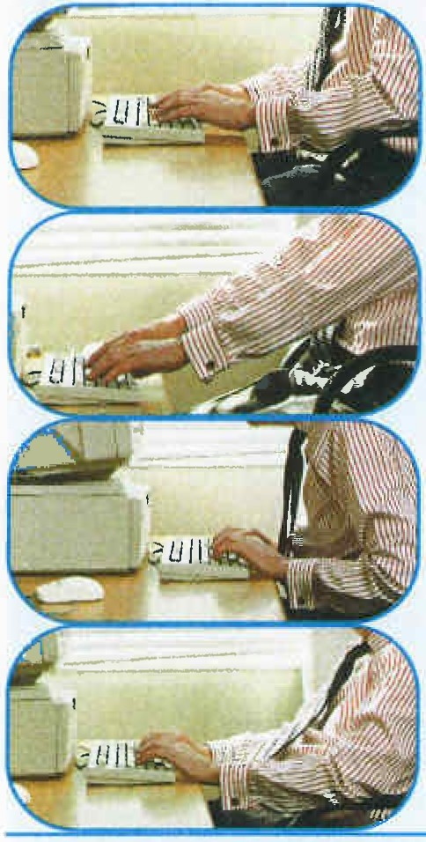

Mouse, trackball etc
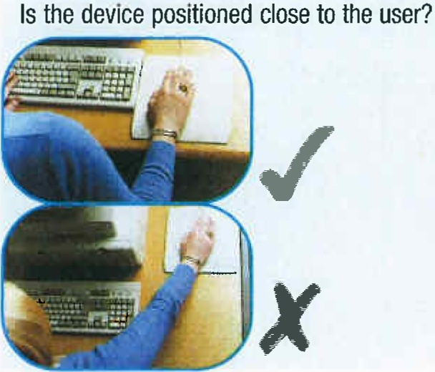

Is the device suitable for the tasks it is
used for?
If the user is having problems, try a different
device. The mouse and trackball are general­ purpose devices suitable for many tasks, and available in a variety of shapes and sizes.
Alternative devices like touch screens may be better for some tasks (but can be worse for others).

Most devices are best placed as close as possible, eg right beside the keyboard.
Training may be needed to:
- prevent arm overreaching;
• tell users not to leave their hand on the device when it is not being used;
• encourage a relaxed arm and straight wrist.

VDU workstation checklist

RISK FACTORS  Is there support for the device user's wrist and forearm? | Tick answer |  | THINGS TO CONSIDER  Support can be gained from, for example, the desk surface or arm of a chair. If not, a separate supporting device may help.  The user should be able to find a comfortable working position with the device. | ACTION TO TAKE
 | YES | NO
Does the device work smoothly at a speed that suits the user? |  |  | See if cleaning is required (eg of mouse ball and rollers).  Check the work surface is suitable.A mouse mat may be needed.
Can the user easily adjust software settings for speed and accuracy of pointer? |  |  | Users may need training in how to adjust device settings.
- Software

Is the software suitable for the task?

Furniture
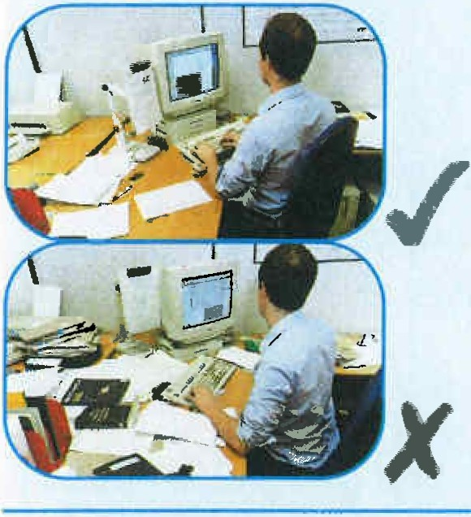

Software should help the user carry out the task, minimise stress and be user-friendly.

Check users have had appropriate training in using the software.

Software should respond quickly and clearly
to user input, with adequate feedback, such as clear help messages.

Is the work surface large enough for  all the necessary equipment , papers etc? |  |  | Create more room by moving printers, reference materials etc elsewhere .  If necessary, consider providing new power and telecoms sockets,so equipment can be moved.  There should be some scope for flexible rearrangement.
Can the user comfortably reach all the equipment and papers they need to use? |  |  | Rearrange equipment, papers etc to bring frequently used things within easy reach.  A document holder may be needed, positioned to minimise uncomfortable head and eye movements.
Are surfaces free from glare and reflection? |  |  | Consider mats or blotters to reduce reflections and glare.

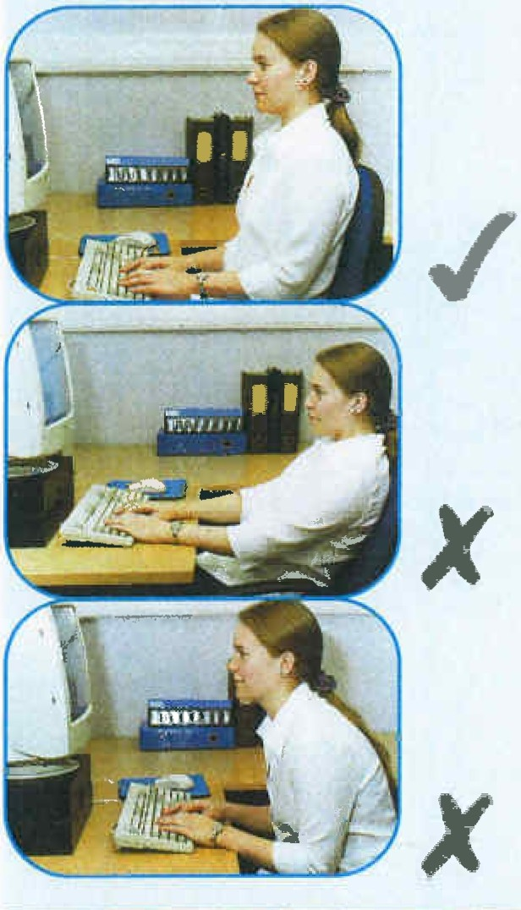

VDU workstation checklist

RISK FACTORS  Is the chair suitable? Is the chair stable?  Does the chair have a working:  - seat back height and tilt adjustment?  - seat height adjustment?  - swivel mechanism?  - castors or glides? | Tick answer |  | THINGS TO CONSIDER  The chair may need repairing or replacing if the user is uncomfortable, or cannot use the adjustment mechanisms. | ACTION TO TAKE
 | YES | NO
Is the chair adjusted correctly? |  |  | The user should be able to carry out their work sitting comfortably.  Consider training the user in how to adopt suitable postures while working.  The arms of chairs can stop the user getting close enough to use the equipment comfortably.  Move any obstructions from under the desk.
Is the small of the back supported by the chair's backrest'? |  |  | The user should have a straight back, supported by the chair, with relaxed shoulders.
Are forearms horizontal and eyes at roughly the same height as the top of the VDU? |  |  | Adjust the chair height to get the user's arms in the right position, then adjust the VDU height,  if necessary.
Are feet flat on the floor, without too much pressure from the seat on the backs of the legs? |  |  | If not, a foot rest may be needed.

RISK FACTORS

Environment
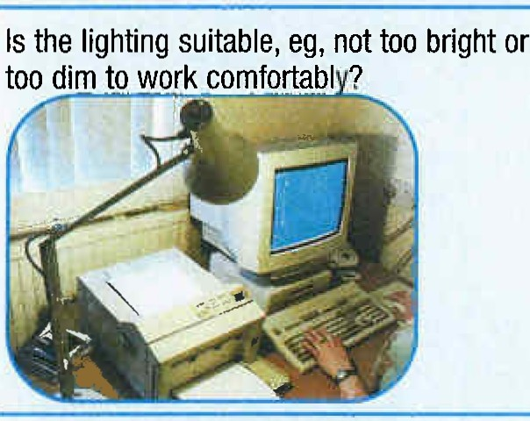

Tick answer THINGS TO CONSIDER YES I NO

ACTION TO TAKE

Is there enough room to change position and vary movement? |  |  | Space is needed to move, stretch and fidget.  Consider reorganising the office layout and check for obstructions.  Cables should be tidy and not a trip or snag hazard.  Users should be able to control light levels, eg by adjusting window blinds or light switches.  Consider shading or repositioning light sources or providing local lighting, eg desk lamps (but make sure lights don't cause glare by reflecting off walls or other surfaces).
_Does the air feel comfortable? |  |  | VDUs and other equipment may dry the air. Circulate fresh air if possible. Plants may help.  Consider a humidifier if discomfort is severe.
Are levels of heat comfortable? |  |  | Can heating be better controlled? More ventilation or air-conditioning may be required if there is a lot of electronic equipment in the room. Or, can users be moved away from the heat source?
Are levels of noise comfortable? |  |  | Consider moving sources of noise, eg printers, away from the user. If not, consider soundproofing.

Final questions to users...

- Ask if the checklist has covered all the problems they may have working with their VDU.

- Ask if they have experienced any discomfort or other symptoms which they attribute to working with their VDU.

- Ask if the user has been advised of their entitlement to eye and eyesight testing.

- Ask if the user takes regular breaks working away from VDUs.

Write the details of any problems here:

Orecycle
When you have finished with this publication please recycle it
50% recycled
This publication is printed on 50% recycled paper

© Crown copyright 2003
Printed and published by Health and Safety Executive

Reprinted 10/07 C375

