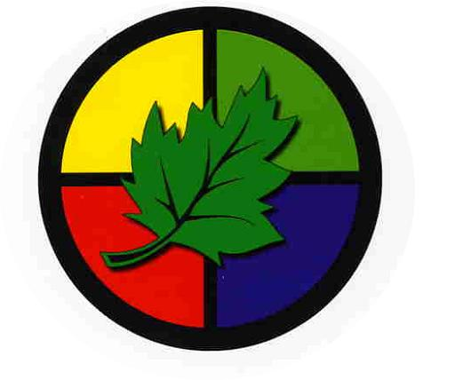
Rivington Primary School
School trips and experience map

 | Autumn | Spring | Summer
Nursery | Visits from people who help us (UW)  Walk to the post box  Church visit (UW) | Teddy Bear’s Picnic (Literacy)  Songfest (EAD)  Easter Egg Hunt (UW)  Live eggs/Caterpillars (UW) | Visit a farm (UW)  Visit Knowsley Safari Park (UW)  Fire service visit (UW)
Reception | Visits from Grandparents  Pumpkin picking (UW)  Pantomime (C+L)  Walk to the post office  Visit Martin Mere  Singing at the local care home  Church visit | Visit Liverpool docs  Walk to the local park  Egg hunt  Visit Bewilderwood (UW) | Visits from people who help us  Cookery workshops  Walk to the library  Visit Manchester airport (UW)  Visit Imagine That (UW)
Year one | Visit to the supermarket (DT)  Visit Warrington Museum (History)  Church visit  Nature walk (Science)  Local area walk (Geography) | Visit the recycling centre (science)  Visit the Transport Museum | Visit Kenyon Hall Farm (Science)  Walk to Cowley to visit their pet’s corner (Science)  Trip to Southport (History)
Year two | Visit River Mersey (Geography)  Visit the Catalyst Museum (Science)  Tour of St Helens: World of glass, Beecham’s clock tower (History).  Church visit (RE) | Visit Victoria Park (science)  Walk to cabbage hall allotments (science)  Visit Liverpool Synagogue (RE) | Visits from people who help us(History)  Walk to Cowley – animation workshop (computing)  Watch the ballet (Art)
Year three | Stone Age Experience Day (History)  Church visit (RE)  Primary Science workshop - forces | Altru Drama Workshop (History)  Gardening (Science)  Catalyst Museum (Science) | Ancient Egyptian Experience Day (History)  Brockholes Nature Reserve (Geography)
Year four | Church Visit (RE)  Litter Picking in the local area | River Trip  Liverpool Museum | Martin Mere Wetland Centre  Manchester Museum
Year five | Visit Liverpool Ganesh temple (RE)  Capoeira (PSHE/PE)  Cookery workshop (DT)  Theatre Trip (Art) | Trip Chester Zoo (Science/Geography)  Trip to Tatton Park (History)  Bikeability  Crucial Crew  Residential Trip | St Helens Chamber Workshop  Visit the recycling centre (Geography)  Wheelchair Sport Event (History/PSHE)
Year six | Visit the local church (RE)  Walk around local area (Geography)  Visit the Imperial War Museum (English) | Visit World Museum (Science)  Science workshop  Robinwood Residential | University Visit (PSHE)

