Cross Country Event
October 2016
On Tuesday 4th October we held our inter-house Cross Country Competition. There were two races per year group, a boys’ race and a girls’ race. Each year group had a set distance they had to run to finish the race. Every runner was racing to finish in the medal positions as well as score points for their house.
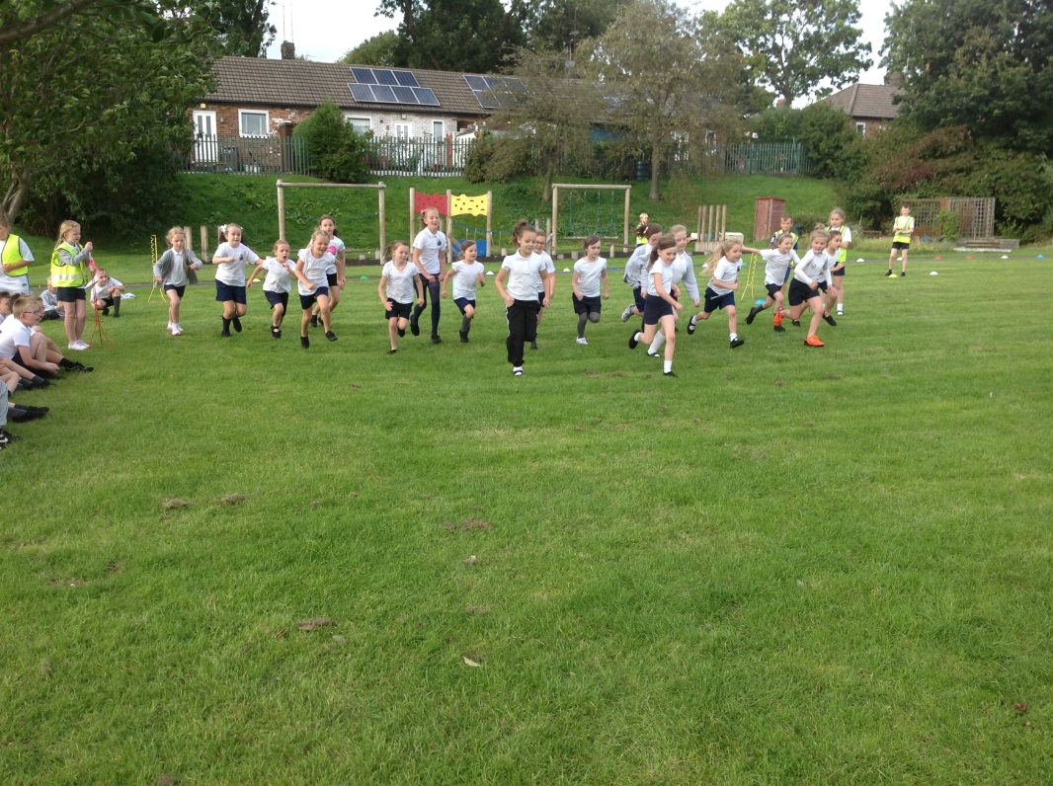
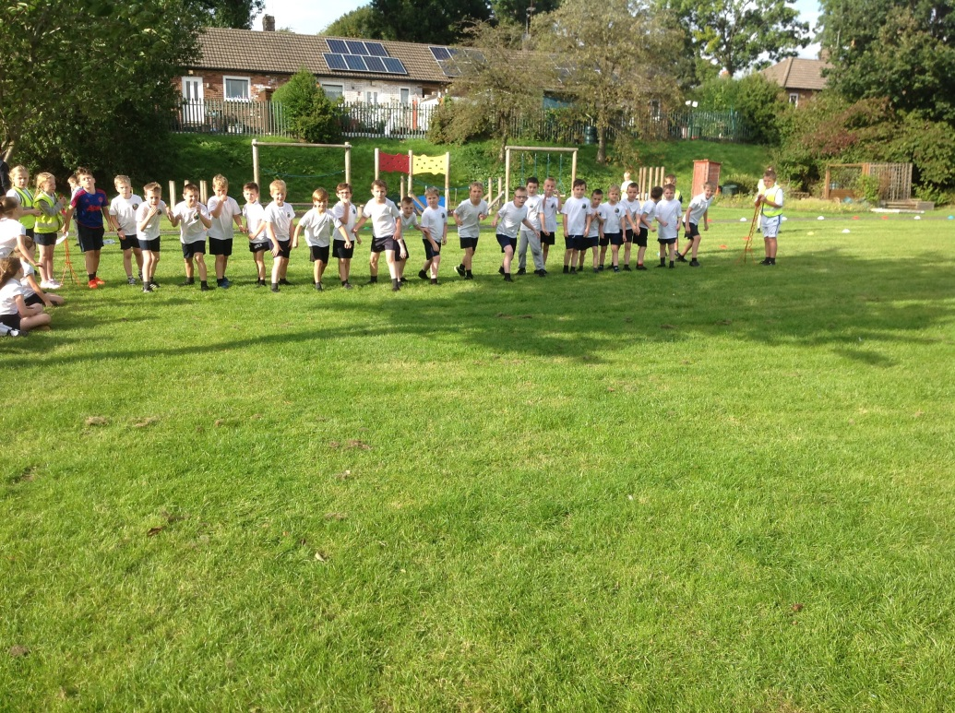

The Sports Committee who had planned and organised the competition with Mrs Latham were out in force during the event participating in stewarding, preparing and decorating the race course and administrative tasks.
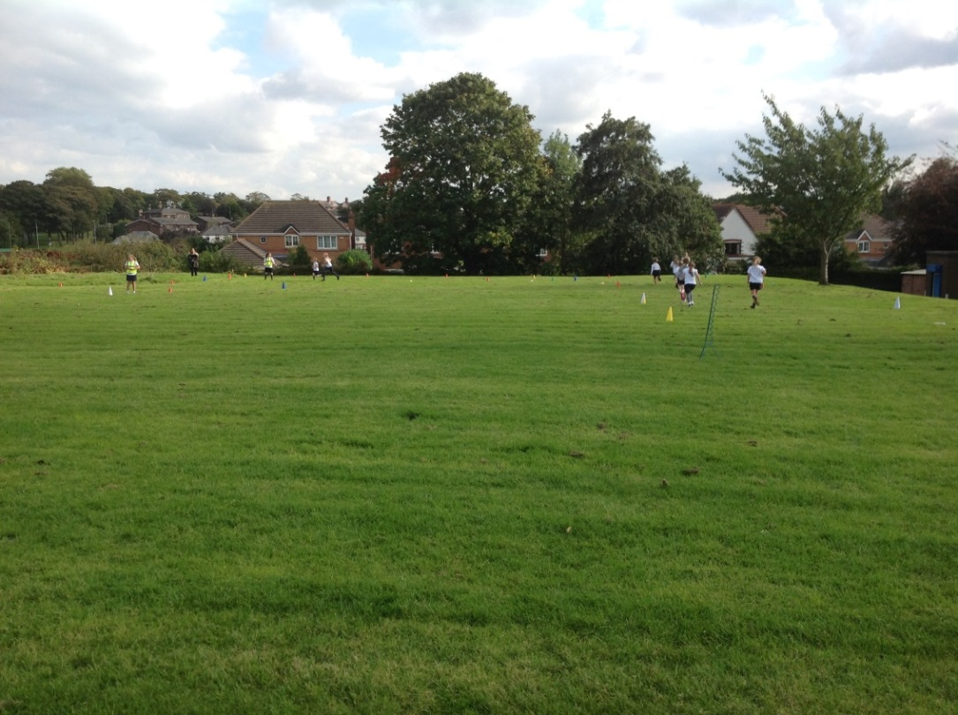
In each race the children showed great sportsmanship, enthusiasm, competitiveness and speed with many of the races ending with a sprint and a photo finish.
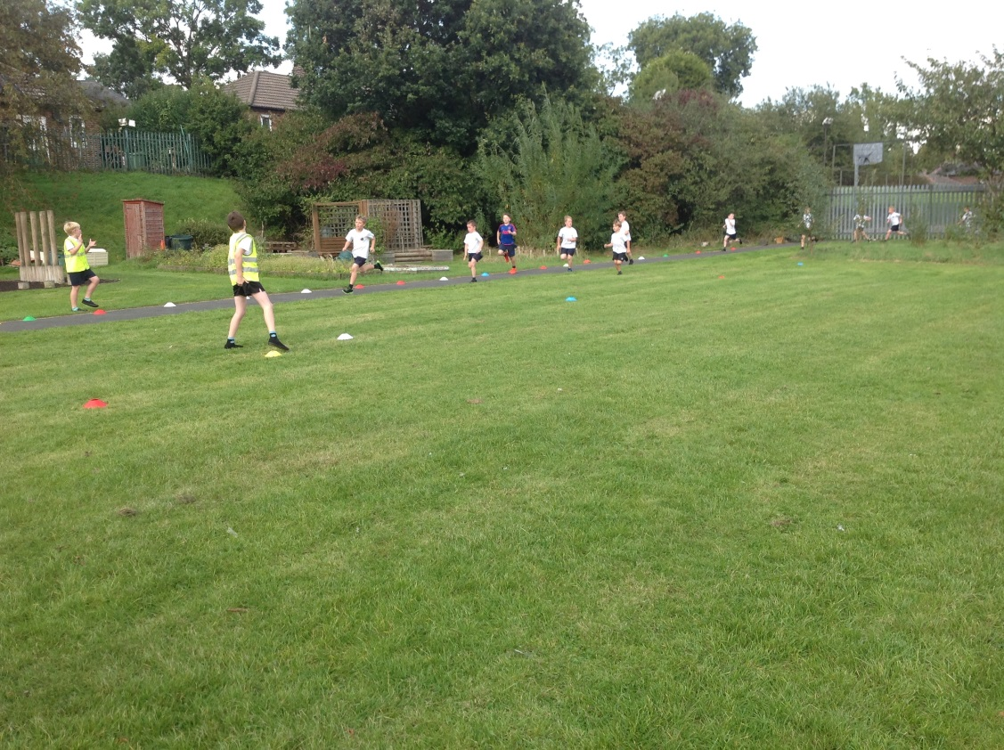
The Year 6 boys’ race was particularly close near the end with Lewis just passing the finishing line first ahead of Samuel.
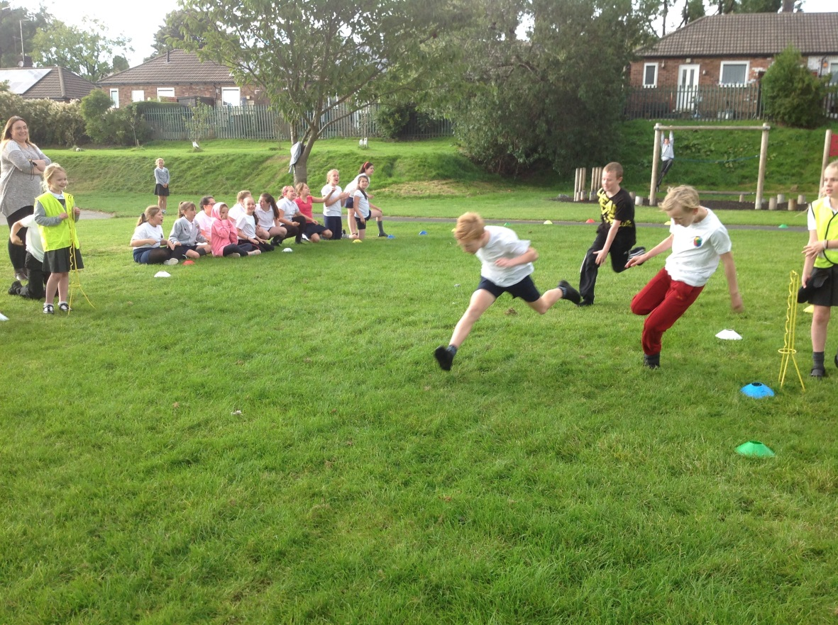
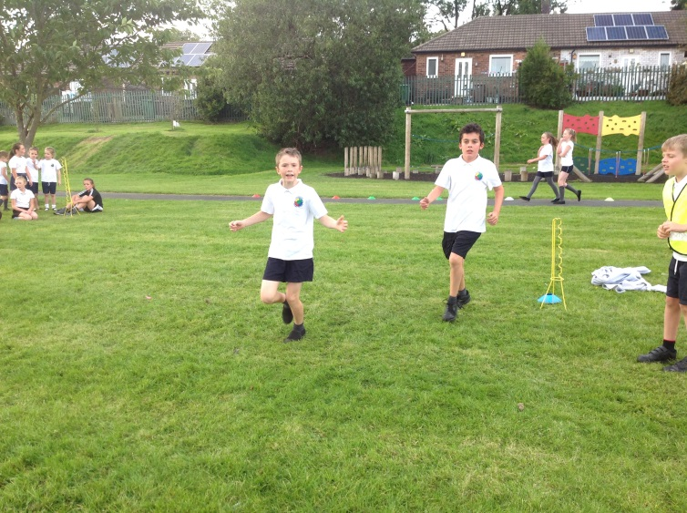
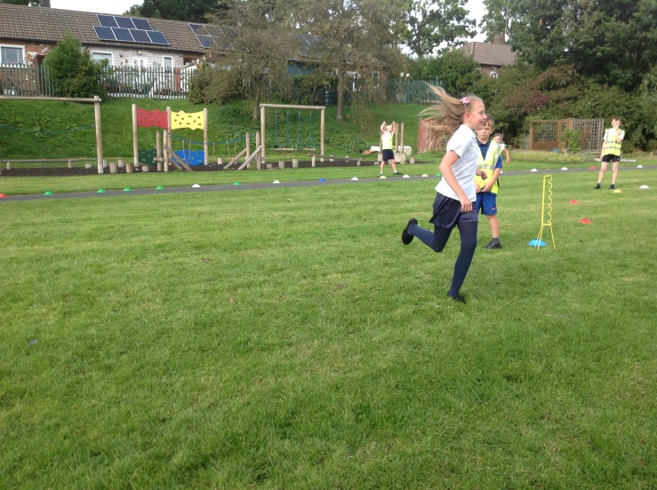
All the children enjoyed the competition throughout the afternoon and were very proud of themselves for completing the course.
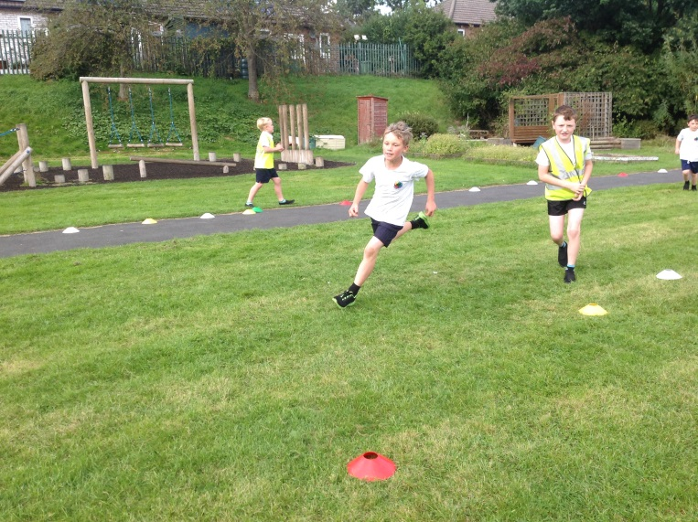

Our Gold Medalists
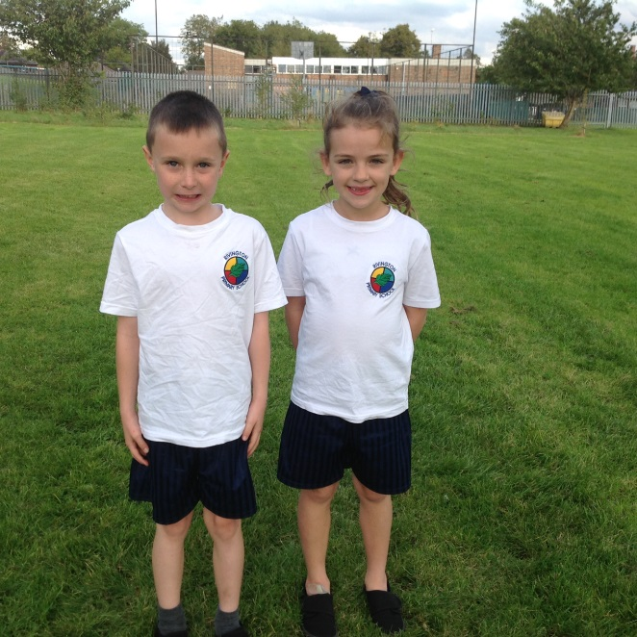
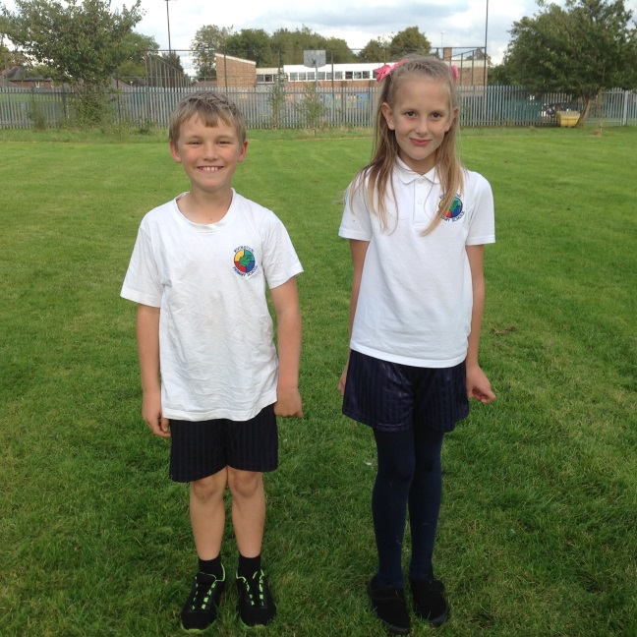
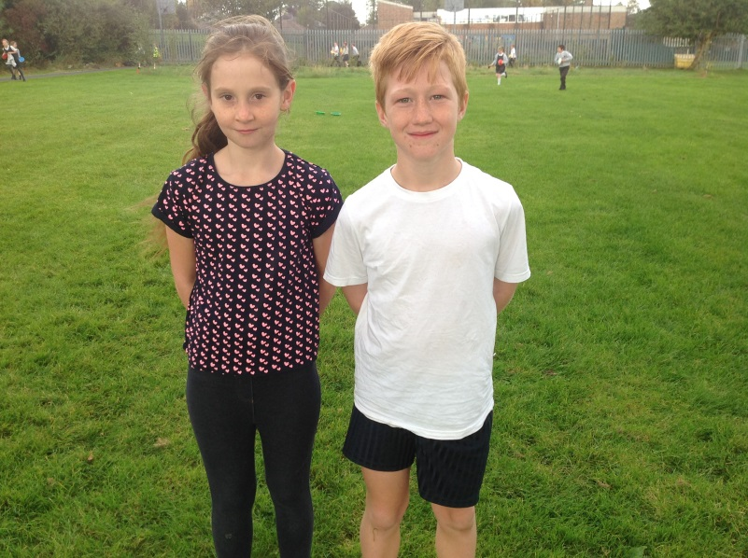
Year 3 Year 4
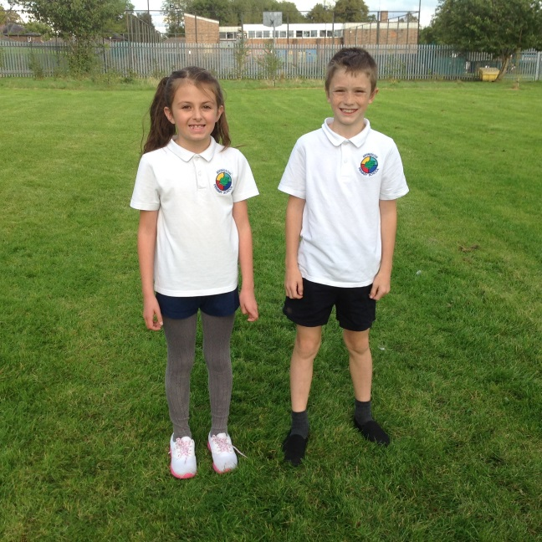
Year 5 Year 6

The Sports Committee presented the medalists in each race with their medals in our whole school merit assembly.
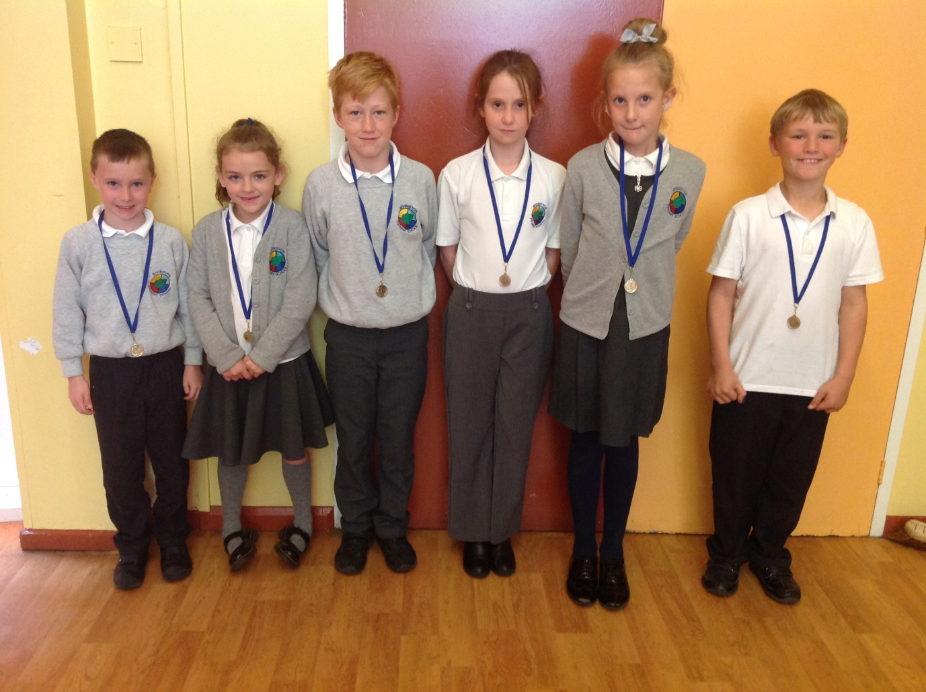
Overall the winning house by an outstanding 22 points was Taylor.

