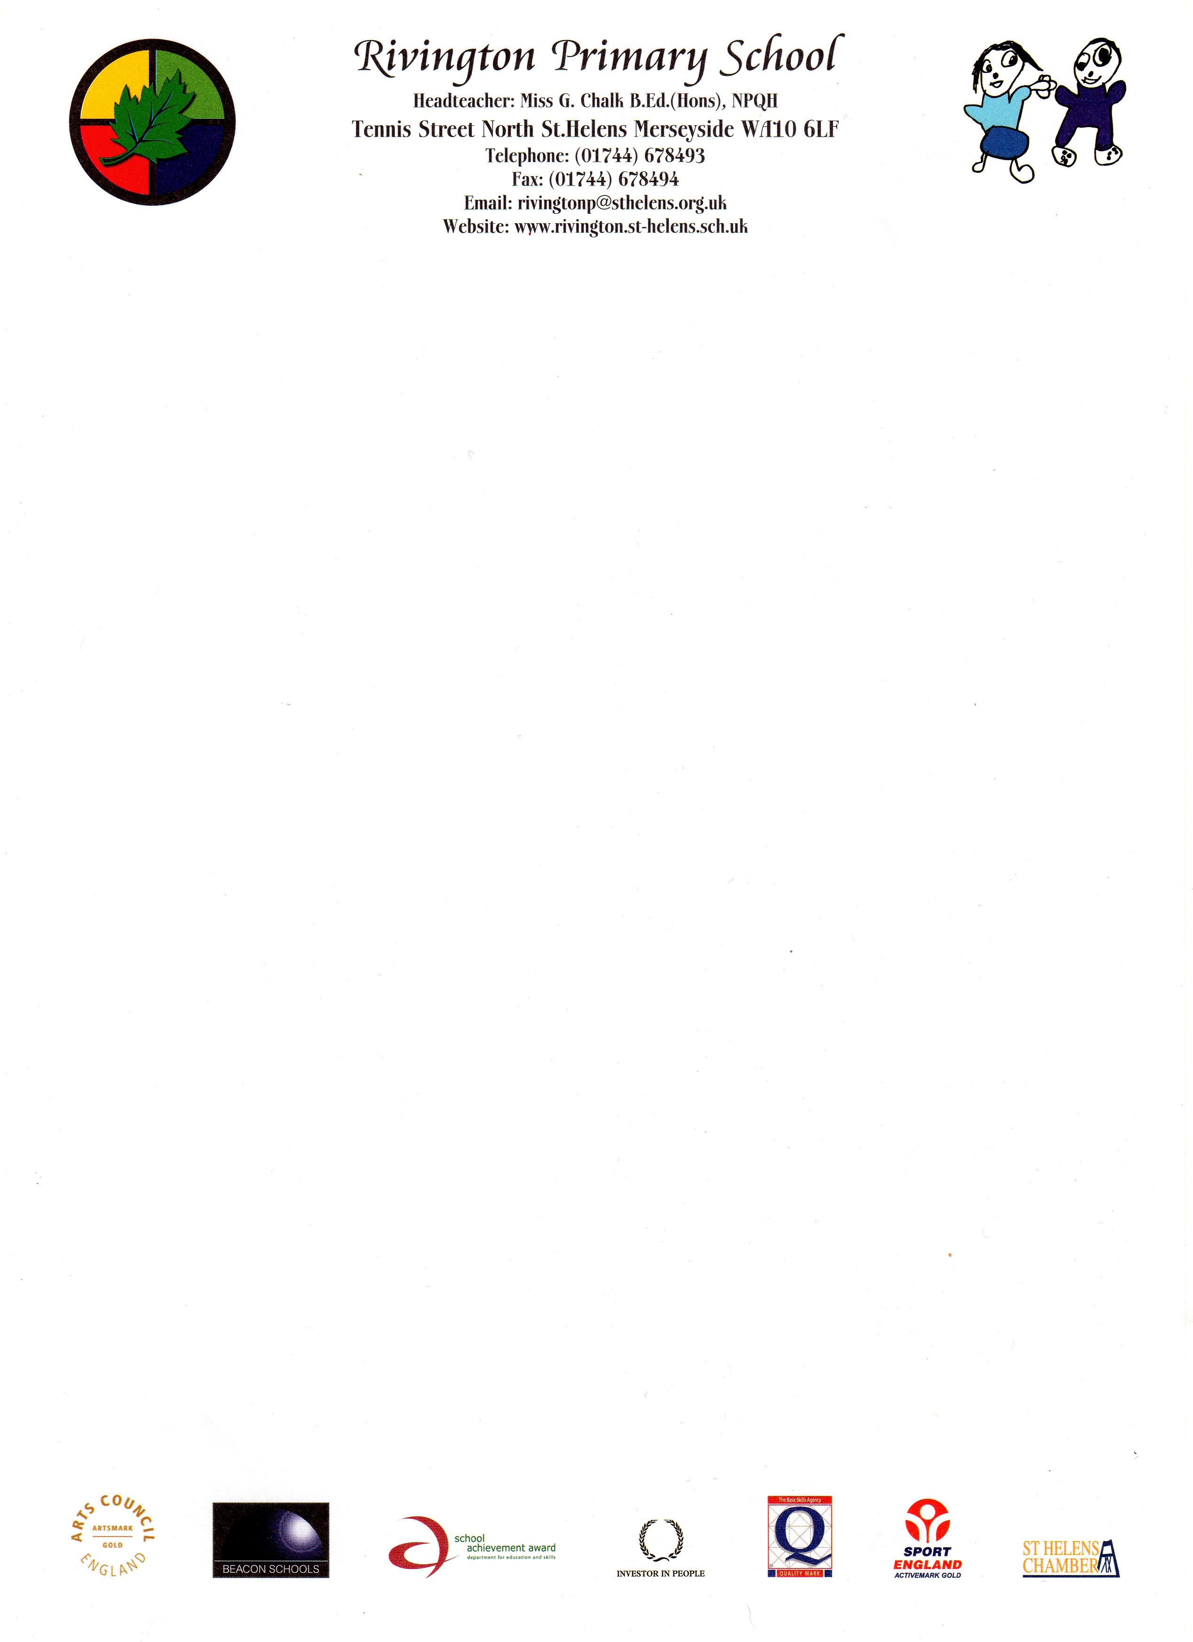

26th September 2016

Dear Parents

The school kitchen has offered to provide a Dino lunch on Thursday 6th October to allow the children who usually have packed lunch to try a school dinner.
Turkey Dinosaurs are on the menu with chips and beans followed by a Gingerbread man.

If your child already has a school meal it will be assumed that they are
taking part and payment will be included in your normal dinner money payment.

If your child is in KS2 and usually has a packed lunch but would like to take part please complete and return the slip below along with your payment of £2.25.

Please remember if your child is in Reception, Y1 or Y2 they are entitled to free school meals.

Please return the slip below by Monday 3rd October.
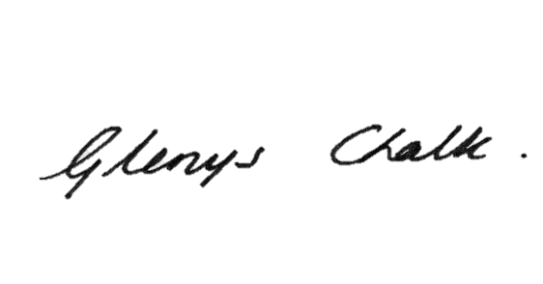
Thank you

Miss Glenys Chalk
Head Teacher

I would like my child………………………………………Class………………
to have a school meal on Thursday 6th October

I enclose a payment of £2.25

My child is eligible for free school meals

but normally brings a packed lunch

Signed…………………………… (Parent/Guardian) Date………………..
Please Print …………...……………………………………………………………...

