RIVINGTON PRIMARY SCHOOL
Respect, Protect, Give Thanks, Keep Peace.

Languages Policy

A place where everyone matters!

Revised December 2022
We believe that 'learning a foreign language is liberation from insularity and provides an opening to other cultures. A high-quality languages education should foster pupils’ curiosity and deepen their understanding of the world. The teaching should enable pupils to express their ideas and thoughts in another language and to understand and respond to its speakers, both in speech and in writing. It should also provide opportunities for them to communicate for practical purposes, learn new ways of thinking and read great literature in the original language. Language teaching should provide the foundation for learning further
languages, equipping pupils to study and work in other countries.' (The National Curriculum in England Framework Document (DfE) 2014)

Our well-balanced curriculum promotes the spiritual, moral, cultural, cultural, mental and physical development of pupils and prepares them for the opportunities, responsibilities and experiences of later life. We will develop pupils' spoken language, reading and writing in all subjects and will develop pupils' mathematical fluency.

Intent

- To ensure that all pupils understand and respond to spoken and written language from a variety of authentic sources.
- To ensure that all pupils speak with increasing confidence, fluency and spontaneity, finding ways of communicating what they want to say, including through discussion and asking questions, and continually improving the accuracy of their pronunciation and intonation.
- To ensure that all pupils can write at varying length, for different purposes and audiences, using the variety of grammatical structures that they have learnt.
- To ensure that all pupils discover and develop an appreciation of a range of writing in the language studied.

(The National Curriculum in England Framework Document (DfE) 2014)

Implementation

At Rivington, our chosen language is Spanish. Spanish is taught in KS2 weekly using the Primary Languages Network scheme. The scheme maps out progression from Y3-Y6 with detailed plans, assessment resources and pre-recorded lessons, ‘Video2Teach’, taught by a native Spanish speaker. The Video2Teach lessons enable the children to experience Spanish being spoken accurately, whilst allowing the teachers to learn alongside the children and teach each lesson at their own pace. The scheme is also available in an alternative format for more confident Spanish speaking teachers to allow for flexibility in their approach, whilst ensuring objectives and progressions are adhered to across the key stage. The network offers CPD for staff which supports teacher understanding and confidence.

Long Term Plan:
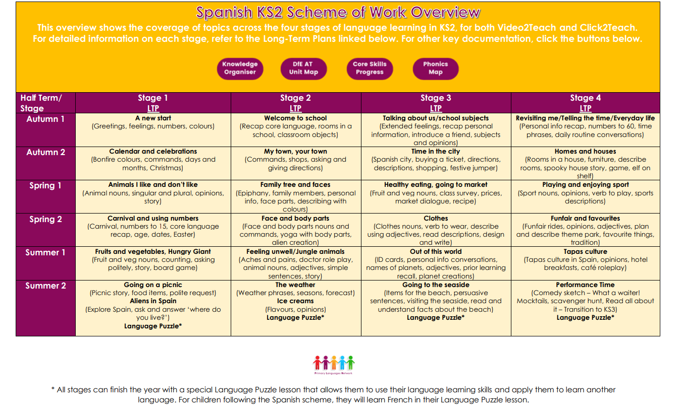

Skills Progression
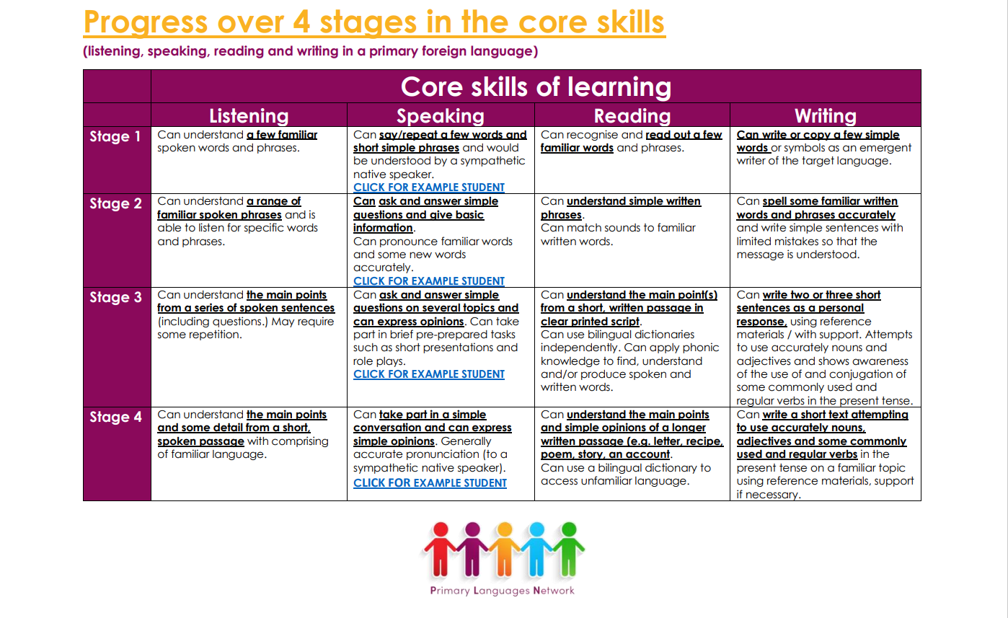

Roles and responsibilities
The governing body
The governing body will approve the Languages policy and hold the Headteacher to account for its implementation.
The Headteacher
The Headteacher is responsible for ensuring that Languages is taught consistently across the school.
Staff
Staff are responsible for:
- Delivering Spanish sessions following the Primary Languages Network scheme.
- Modelling positive attitudes to learning languages and learning about other cultures.
- Monitoring progress
- Responding to the needs of individual children
- Delivering the curriculum without promoting their own personal viewpoint
All teachers are responsible for the teaching of Spanish and all teaching assistants are responsible for supporting the teaching of Spanish.

Monitoring arrangements
The delivery of Spanish is monitored by the Languages Lead, Senior Leadership Team and the governors, through learning walks, pupil interviews and governors meetings. Children’s development in Spanish is monitored by class teachers.

Equality
The DfE Guidance 2019 (p. 15) states, “Schools should ensure that the needs of all pupils are appropriately met, and that all pupils understand the importance of equality and respect. Schools must ensure they comply with the relevant provisions of the Equality Act 2010 under which sexual orientation and gender reassignment are amongst the protected characteristics.

SEND
Teachers will plan in different ways and use a variety of teaching strategies to meet the needs of individuals. For some children, particularly those with special educational needs and disabilities, a tailored approach may be necessary to ensure learning outcomes are met – if so, this will be discussed with parents/carers and based upon the individual needs of the pupil.

Resources
We have number of Languages books and dictionaries in school which can be supplemented by loans from the Schools Library Service. There are also a number of role play boxes which contain items that can support learning about culture through an active learning approach.

